Question 1. Implement an android function to capture a focal stack (5 Points)

Answer:

Android Studio Codes

public void captureFocalStack(View v) {  
 //*TODO:hw5* //getting min and max focusdistance  
 //Range<Long> focalRange = characteristics.get(CameraCharacteristics.);  
 float minimumLens = characteristics.get(CameraCharacteristics.*LENS_INFO_MINIMUM_FOCUS_DISTANCE*);  
 float maximumLens = characteristics.get(CameraCharacteristics.*LENS_INFO_HYPERFOCAL_DISTANCE*);  
 Log.*e*(*TAG*, "minimumLens: " + minimumLens);  
 Log.*e*(*TAG*, "maxmimumLens: " + maximumLens);  
 //*TODO:hw5* //setting previous lens to be min or max focus distance. (guess which one it is!)  
 float prev_focus = maximumLens;  
 Log.*e*(*TAG*, "in captureFocalStack");  
 //check if capture session is null  
 if (mCaptureSession != null) {  
 Log.*e*(*TAG*, "prevLens: " + prev_focus);  
 //*TODO: check if focus distance after changing is in range* while (prev_focus * 1.5 < minimumLens) {  
 //sleep system clock for 20 ms  
 SystemClock.*sleep*(20);  
 Log.*e*(*TAG*, "in captureFocalStack while loop");  
 try {  
 //*TODO: set current focus to be 1.5 * previous focus* float curr_focus = (float)1.5 * prev_focus;  
 focuses.add(curr_focus);  
 //build requester  
 CaptureRequest.Builder requester =  
 mCameraDevice.createCaptureRequest(mCameraDevice.*TEMPLATE_STILL_CAPTURE*);  
 //*TODO: turn off auto focus mode for requester* requester.set(CaptureRequest.*CONTROL_AF_MODE*, CaptureRequest.*CONTROL_AF_MODE_OFF*);  
 //add surface as target in requester  
 requester.addTarget(mCaptureBuffer.getSurface());  
 //*TODO: set current focus to requester* requester.set(CaptureRequest.*LENS_FOCUS_DISTANCE*, curr_focus);  
 //set previous focus = current focus  
 prev_focus = curr_focus;  
 try {  
 // This handler can be null because we aren't actually attaching any callback  
 //make capture session  
  
 mCaptureSession.capture(requester.build(), /*listener*/null, /*handler*/null);  
 } catch (CameraAccessException ex) {  
 Log.*e*(*TAG*, "Failed to file actual capture request", ex);  
 }  
 } catch (CameraAccessException ex) {  
 Log.*e*(*TAG*, "Failed to build actual capture request", ex);  
 }  
 }  
 } else {  
 Log.*e*(*TAG*, "User attempted to perform a capture outside the session");  
 }  
  
}

I found the minimumLens is 0.67 and the maximumLens is 10. So just 6 pictures were saved and focus situations are bad. To solve the problem, I set different positions of the objects to get appropriate focus on them. Finally, I chose focus = 3.375, 5.0625 and 7.59375. Three images are as follows.

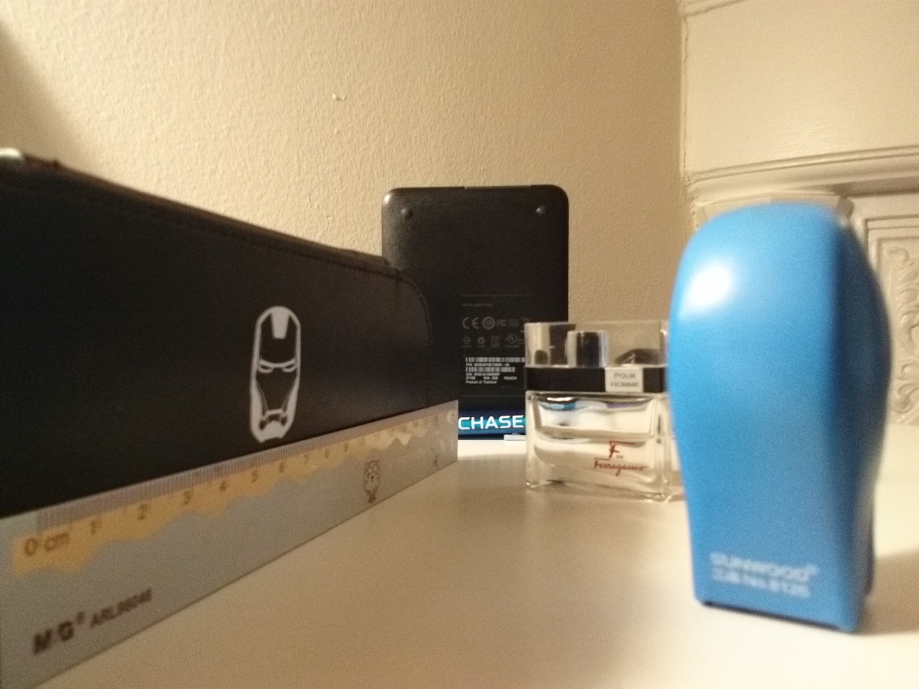

Figure 1. focus = 3.375

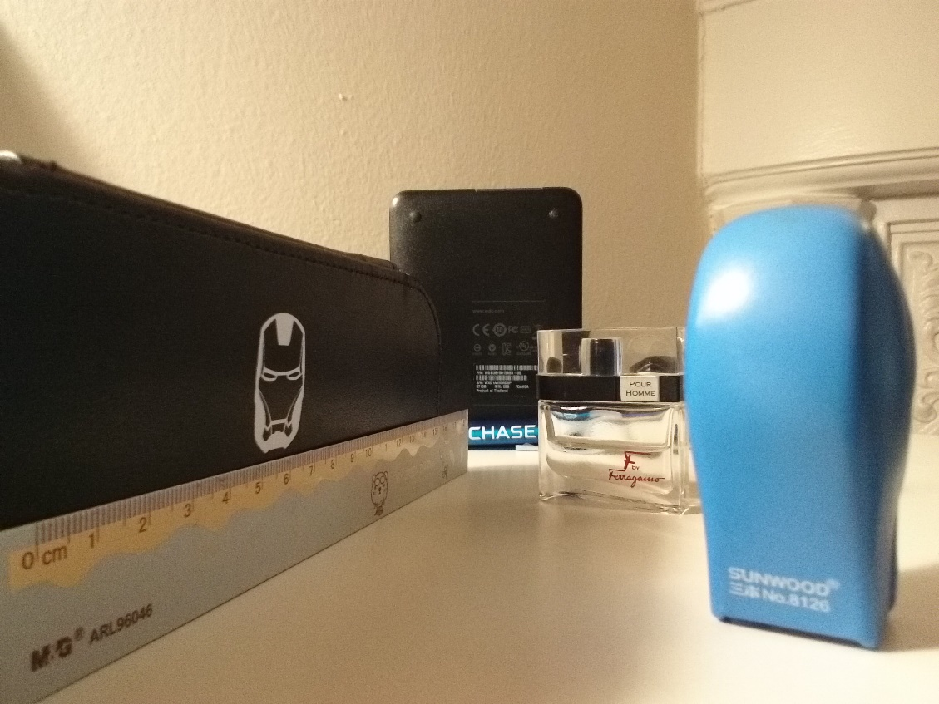

Figure 2. focus = 5.0625

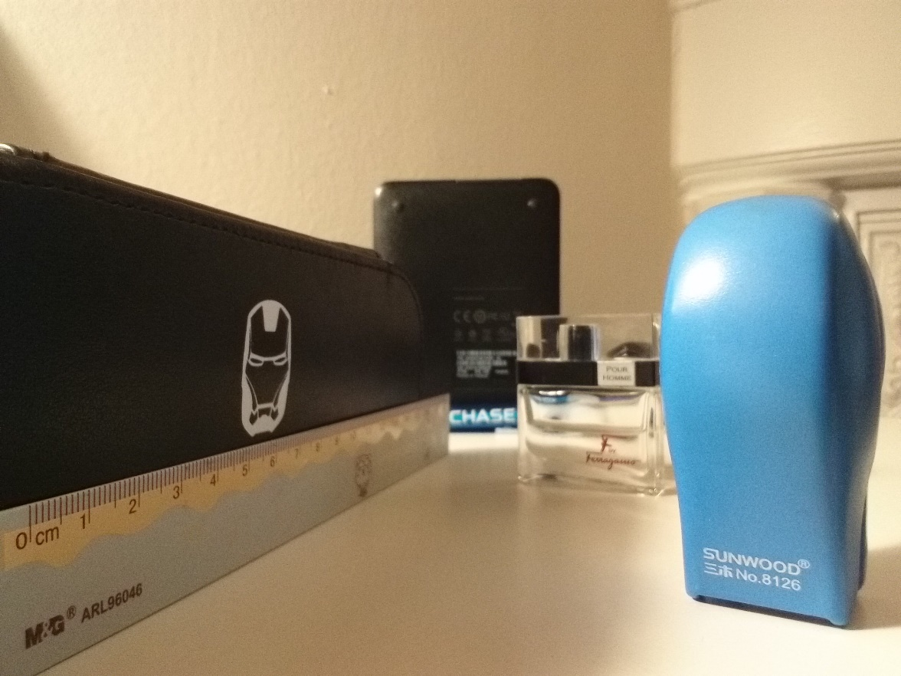

Figure 3. focus= 7.59375

Question 2. Calibrate your focal stack (2 Points)

Answer:

When calibrating the three images, there is something wrong with the magnitude which makes the calibrating is not accurate. However, I tried several parameters and found multiplying their focus by 1.5 can get almost perfect results of calibration. The results are as follows.

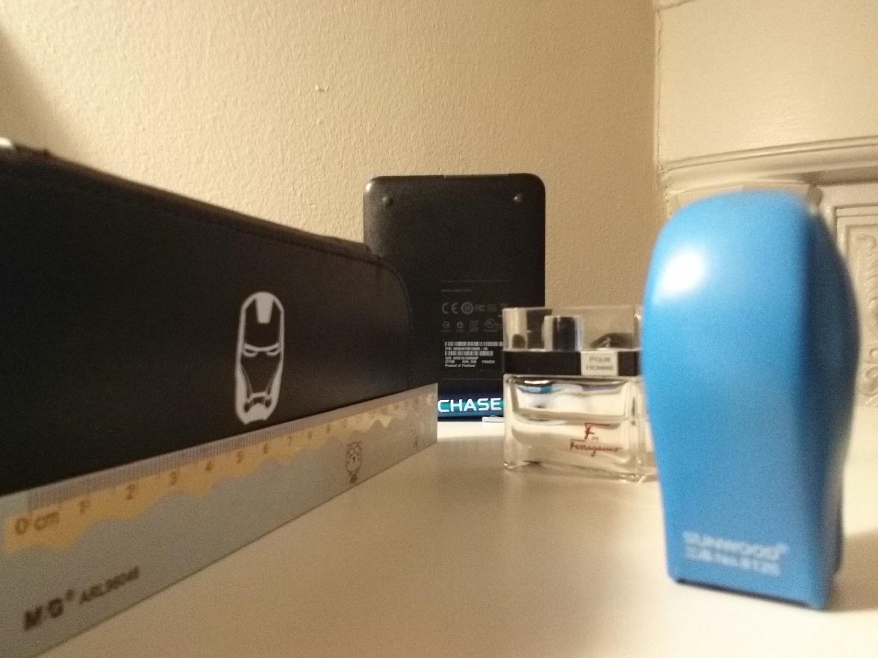

Figure 4. focus = 3.375, calibrated

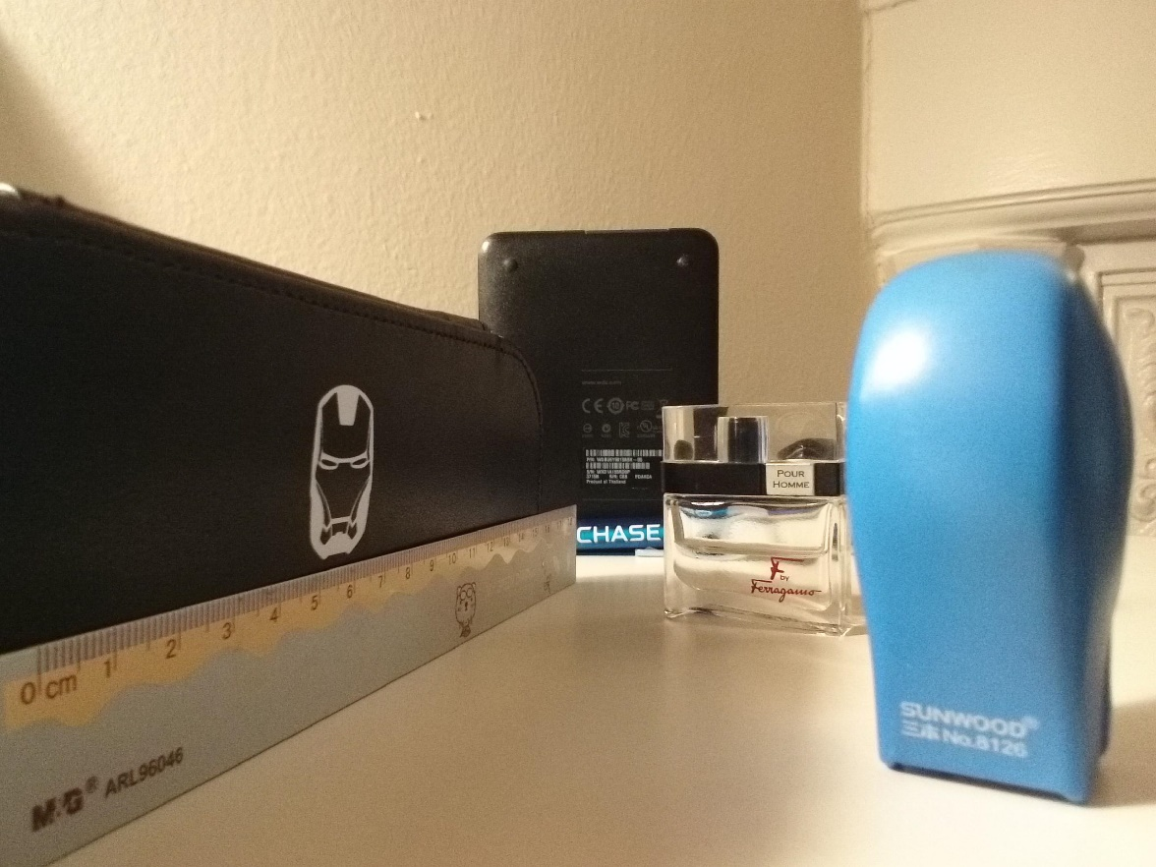

Figure 5. focus = 5.0625, calibrated

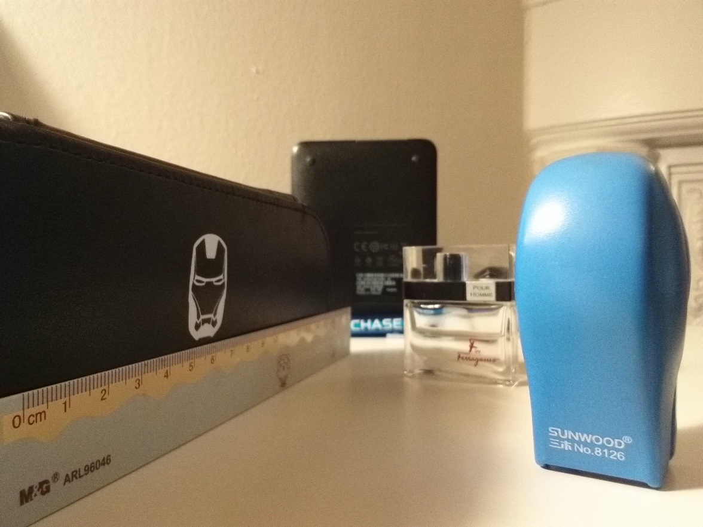

Figure 6. focus = 7.5975 calibrated

Matlab Codes

clear;

clc;

k=3;

Iori=cell(k,1);

U=zeros(k,1);

f=2.95;

Vkstack=[1.5^4;1.5^5;1.5^6];

for i=1:k

U(i)=1/(339-Vkstack(i));

end

for i=1:k

imgname=strcat('D:\Courses Files_2015_Fall\Introduction to Computational Photography\HW5\',num2str(i),'.jpg');

Iori{i}=im2double(imread(imgname));

end

Icalib=calibrate(Iori,k,U);

function Iout=calibrate(Iin,k,U)

Iout=cell(k,1);

for i=1:k

red=Iin{i}(:,:,1);

green=Iin{i}(:,:,2);

blue=Iin{i}(:,:,3);

[m,n]=size(red);

mi=U(i)/U(k);

for a=1:m

for b=1:n

if a<=m/2

a2=round(m/2-abs(a-m/2)*mi);

end

if a>m/2

a2=round(m/2+abs(a-m/2)*mi);

end

if b<=n/2

b2=round(n/2-abs(b-n/2)*mi);

end

if b>n/2

b2=round(n/2+abs(b-n/2)*mi);

end

rcalib(a,b)=red(a2,b2);

gcalib(a,b)=green(a2,b2);

bcalib(a,b)=blue(a2,b2);

end

end

Iout{i}(:,:,1)=rcalib;

Iout{i}(:,:,2)=gcalib;

Iout{i}(:,:,3)=bcalib;

imgname=strcat('calibrated',num2str(i),'.jpg');

imwrite(Iout{i},imgname,'jpeg');

end

Question 3. Compute a depth map from the focal stack (3 Points)

Answer:

K was set as 1, 2,3,5 and 7. Results are as follows.

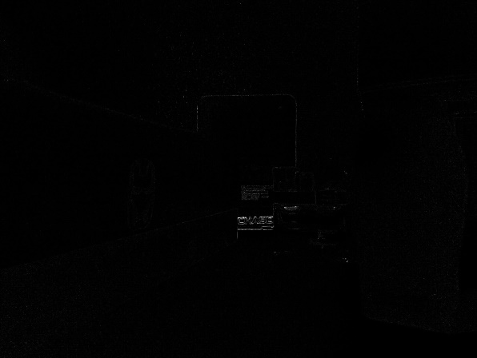 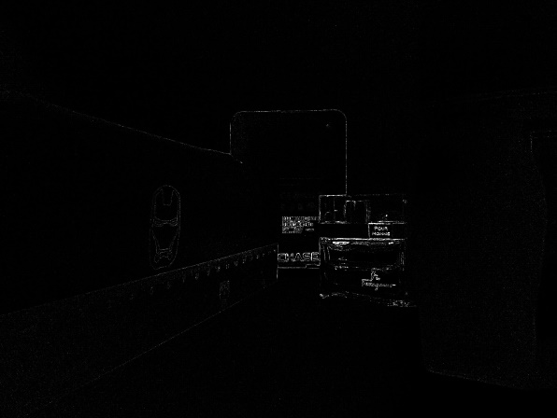

Figure 7. focus = 3.375 depth map, K=1 Figure 8. focus = 5.0625 depth map, K=1

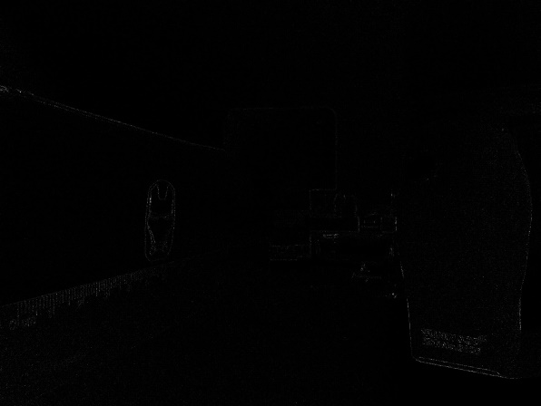 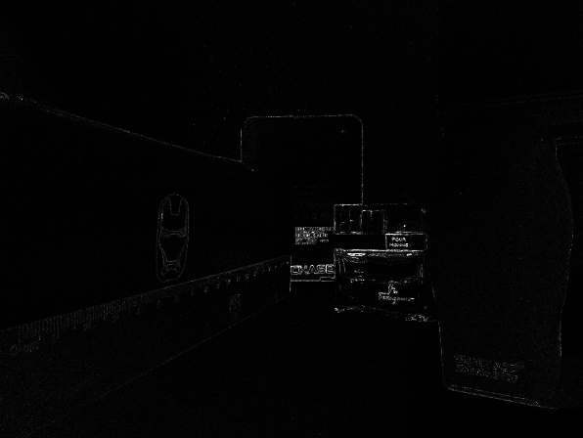

Figure 9. focus = 7.5975 depth map, K=1 Figure 10. depth map combined, K=1

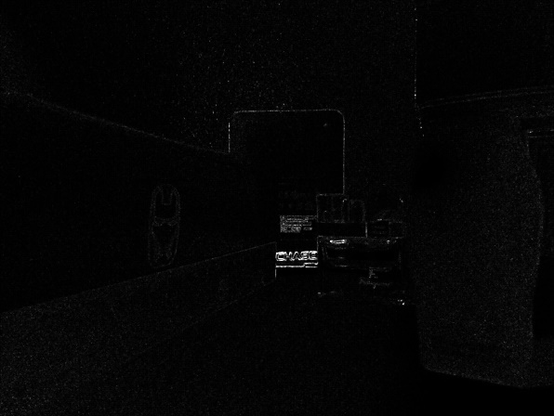 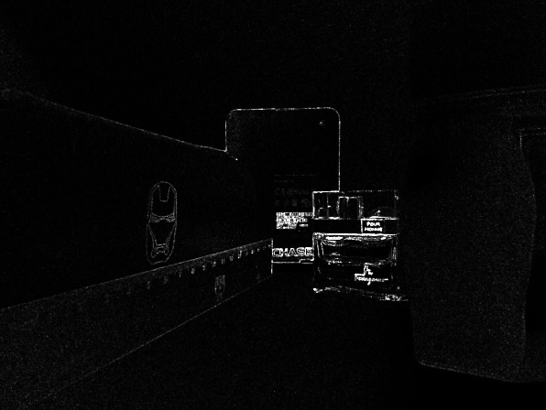

Figure 11. focus = 3.375 depth map, K=2 Figure 12. focus = 5.0625 depth map, K=2

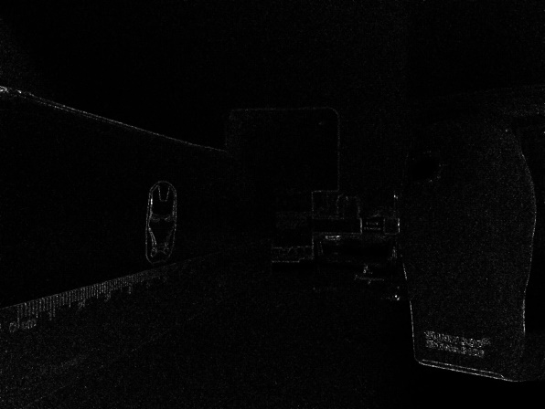 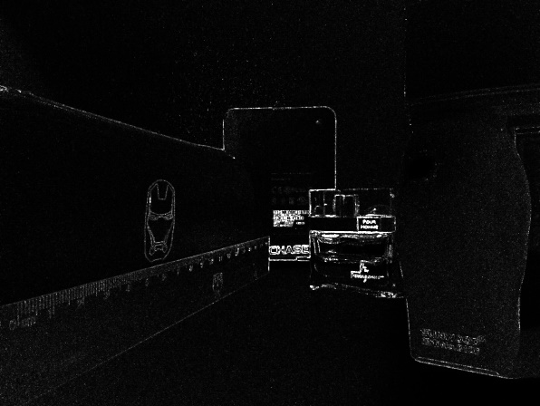

Figure 13. focus = 7.5975 depth map, K=2 Figure 14. depth map combined, K=2

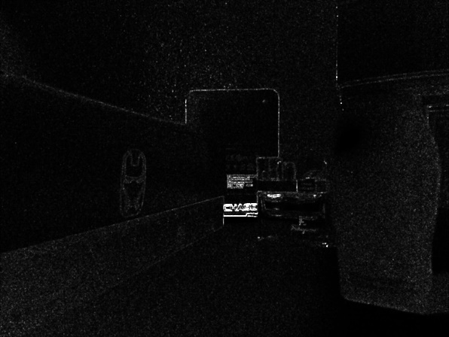 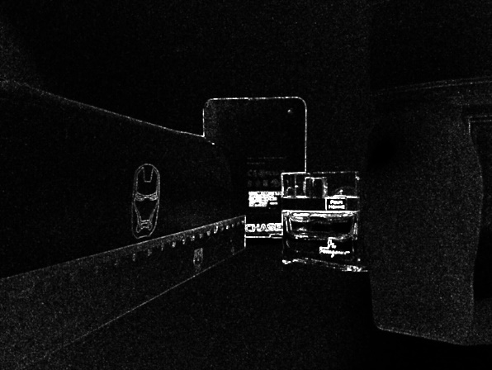

Figure 15. focus = 3.375 depth map, K=3 Figure 16. focus = 5.0625 depth map, K=3

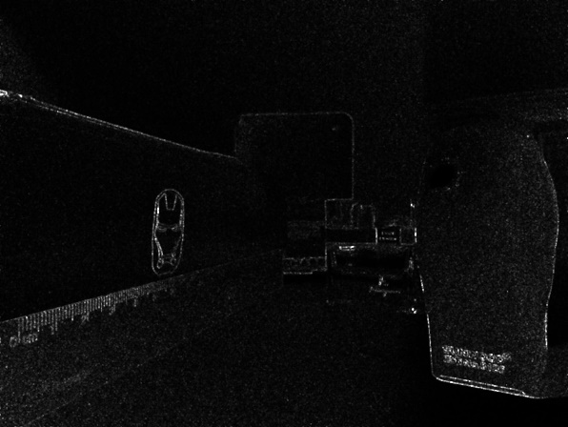 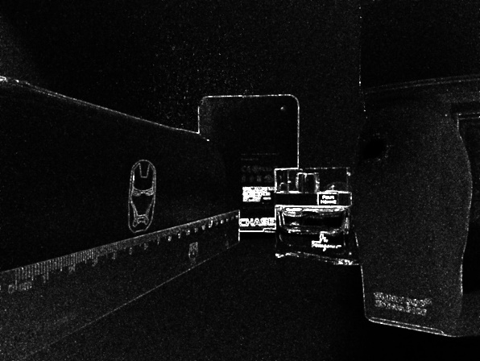

Figure 17. focus = 7.5975 depth map, K=3 Figure 18. depth map combined, K=3

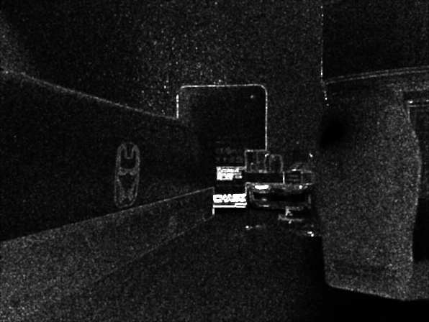 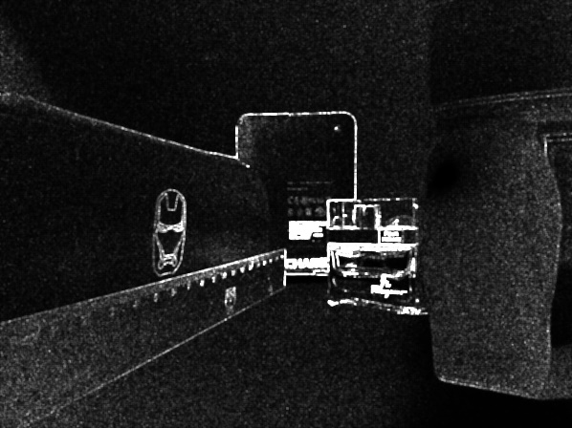

Figure 19. focus = 3.375 depth map, K=5 Figure 20. focus = 5.0625 depth map, K=5

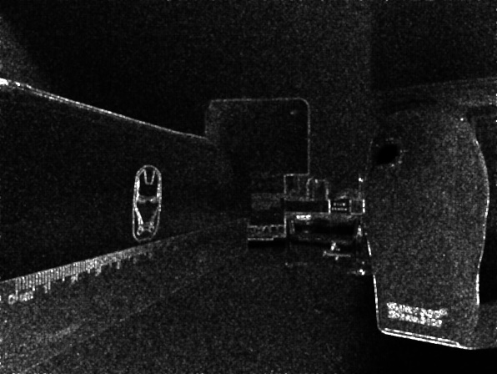 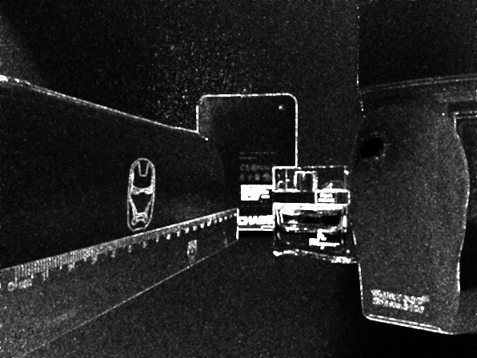

Figure 21. focus = 7.5975 depth map, K=5 Figure 22. depth map combined, K=5

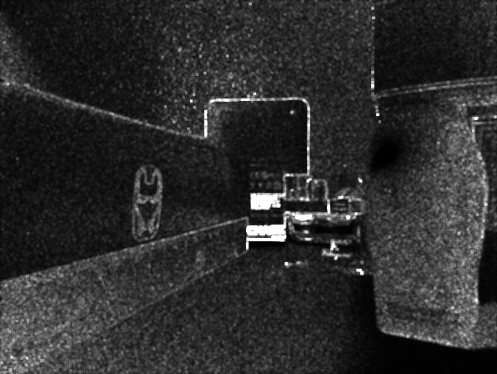 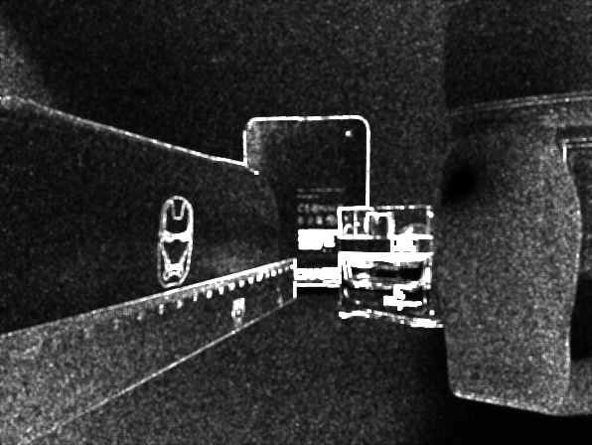

Figure 23. focus = 3.375 depth map, K=7 Figure 24. focus = 5.0625 depth map, K=7

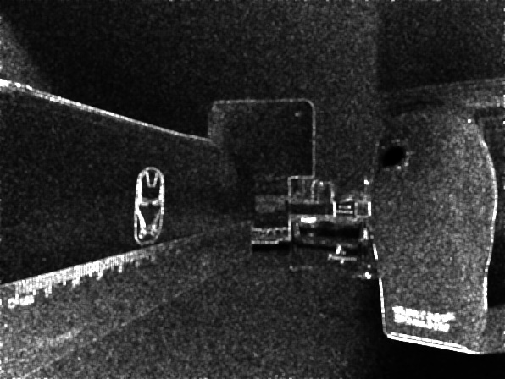 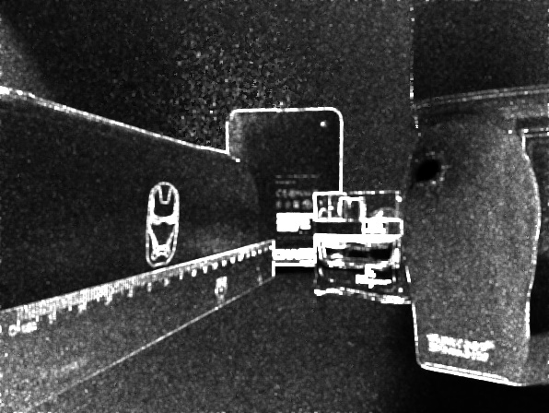

Figure 25. focus = 7.5975 depth map, K=7 Figure 26. depth map combined, K=7

Matlab Codes

Igray=graytransformation(Icalib,k);

Ilaplacian=Laplacian(Igray,k);

IM=recover(Ilaplacian,k,5);

[Imap,Icomb]=compare(IM);

function Iout=graytransformation(Iin,k)

Iout=cell(k,1);

for i=1:k

Iout{i}=rgb2gray(Iin{i});

end

function Iout=Laplacian(Iin,k)

Iout=cell(k,1);

mask=[1 4 1;

4 -20 4

1 4 1]/6;

for i=1:k

Iout{i}=imfilter(Iin{i},mask,'replicate');

Iout{i}=Iout{i}.*Iout{i};

end

function Iout=recover(Iin,k,K)

Iout=cell(k,1);

[m,n]=size(Iin{1});

for i=1:k

Iout{i}=zeros(m,n);

end

for a=1:k

for b=1:m

for c=1:n

for i=-K:K

for j=-K:K

d=b+i;

e=c+j;

while d<=0

d=d+1;

end

while d>m

d=d-1;

end

while e<=0

e=e+1;

end

while e>n

e=e-1;

end

Iout{a}(b,c)=Iout{a}(b,c)+Iin{a}(d,e);

end

end

end

end

imgname=strcat('M k= ',num2str(a),'.jpg');

imwrite(Iout{a},imgname,'jpeg');

end

end

function [Iout1,Iout2]=compare(Iin)

[m,n]=size(Iin{1});

Iout1=zeros(m,n);

Iout2=Iin{1};

for i=1:m

for j=1:n

Iout1(i,j)=1;

if Iin{2}(i,j)>Iin{1}(i,j)

Iout1(i,j)=2;

Iout2(i,j)=Iin{2}(i,j);

end

if Iin{3}(i,j)>Iin{2}(i,j)

Iout1(i,j)=3;

Iout2(i,j)=Iin{3}(i,j);

end

end

end

imwrite(Iout2,'depth index map.jpg','jpeg');

end

Question 4. Recover an all-focus image of the scene (5 Points)

Answer:

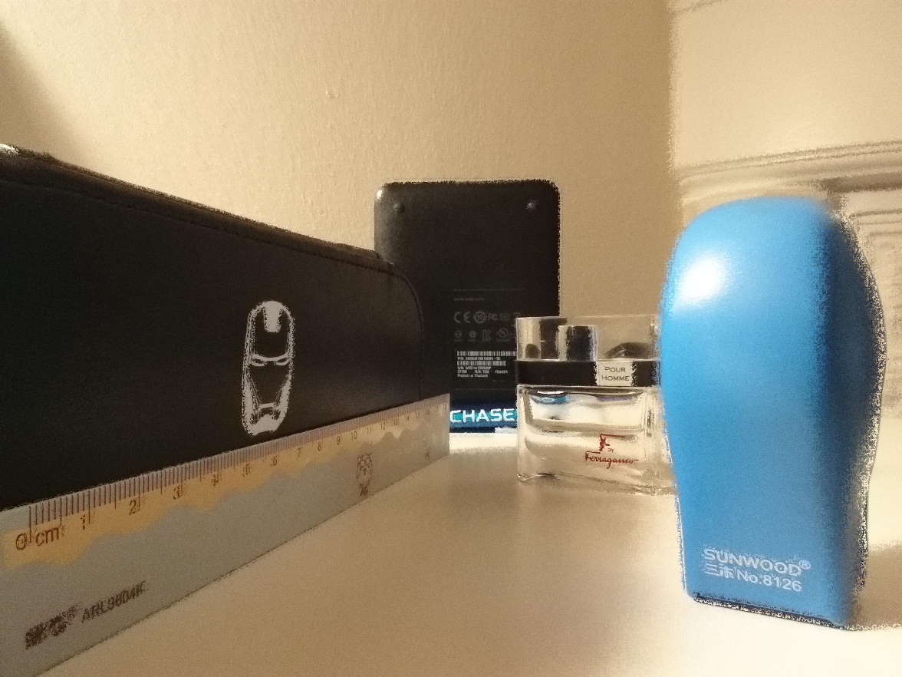

Figure 27. final result, K=1

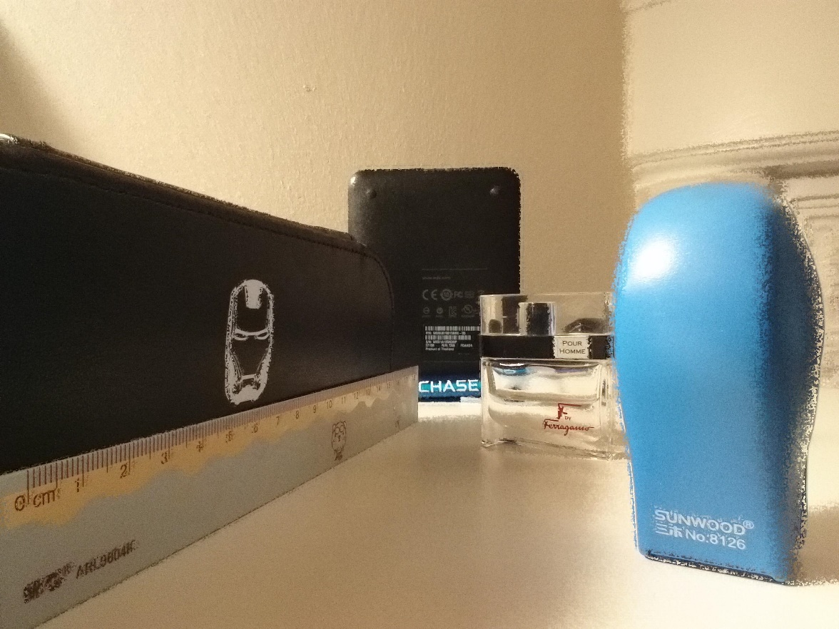

Figure 28. final result, K=2

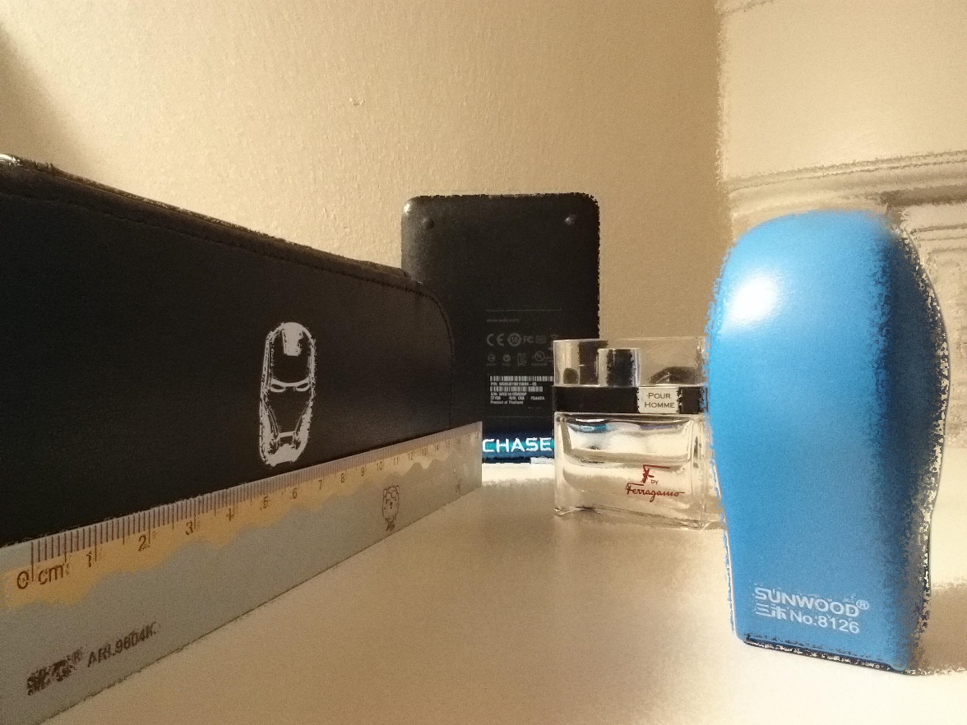

Figure 29. final result, K=3

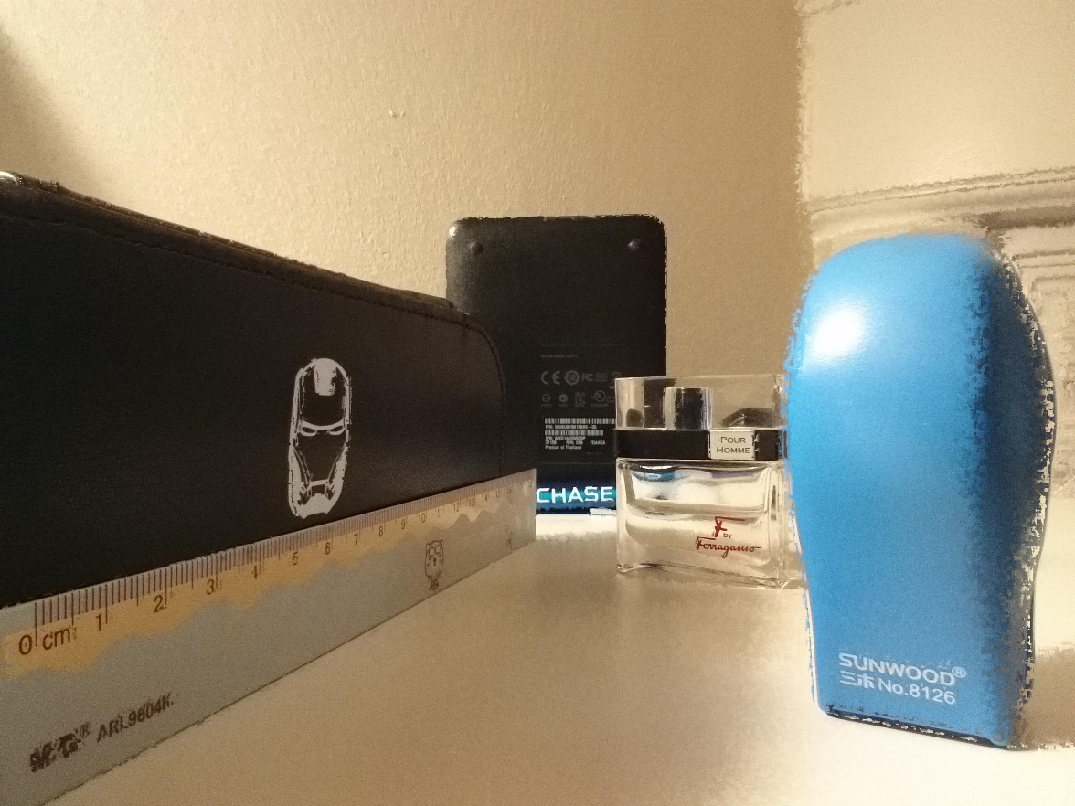

Figure 30. final result, K=5

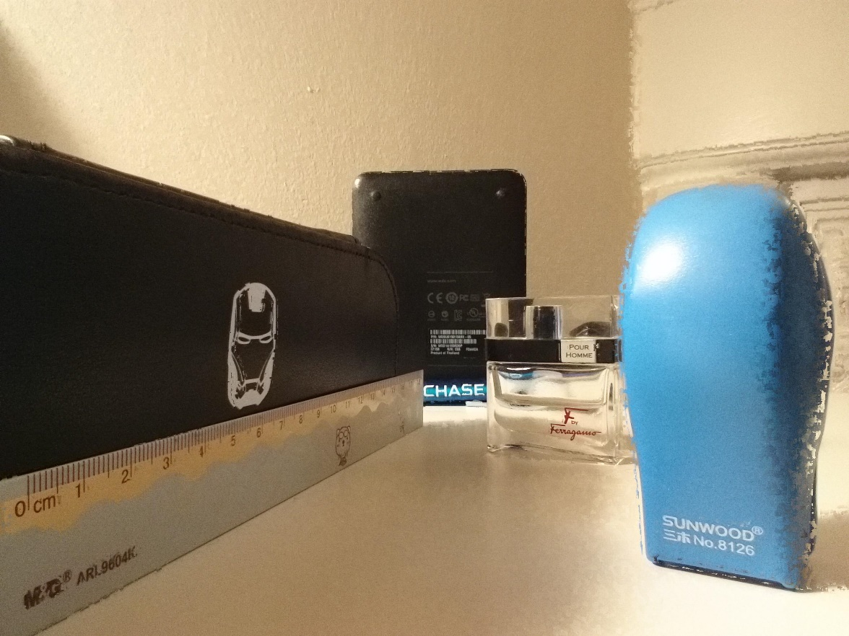

Figure 31. final result, K=7

Comparing the results we can see that as K increases, the all-in focus image get better and better.

Matlab Codes

[m,n]=size(Imap);

Ifinal=zeros(m,n,3);

for i=1:m

for j=1:n

Ifinal(i,j,1)=Iori{Imap(i,j)}(i,j,1);

Ifinal(i,j,2)=Iori{Imap(i,j)}(i,j,2);

Ifinal(i,j,3)=Iori{Imap(i,j)}(i,j,3);

end

end

figure(),imshow(Ifinal);

imwrite(Ifinal,'Ifinal.jpg','jpeg');

Problems encountered:

1. From the Tablet, the minimumLens I got is larger than maximumLens. After discussing with professor Oliver and TA, I know focal distances are units of diopters.
2. Before calibration, we need multiply the focus distance by 1.5.